**1) How does Basement height, condtions and exposure effect the sales of the property ?**

**Ans)**

**Basement Height :** Basement conditions truly effect the sales of the property. Basement height with 100 inches has the highest sales in property.Also most of the customers are having interest towards 90 – 99 inches more. And 100 inches height has a minimum user count.When height of basement is 90-99 inches then sales price is okay. When height of basement decreased to 80 - 89 inches from 90 - 99 inches then Sale Price also decreased. As basement height increases sales price also increases which means both are linearly dependent on each other. This can be observed in below image.

**Conclusion :** In future company need to construct basements with 100+ inches , 90 – 99 inches, 80 -89 inches more. Basements with heights 70 – 79 inches and less then 70 inches need to be constructed less in amount. These inturn help in gaining Sales Amount from buyers.

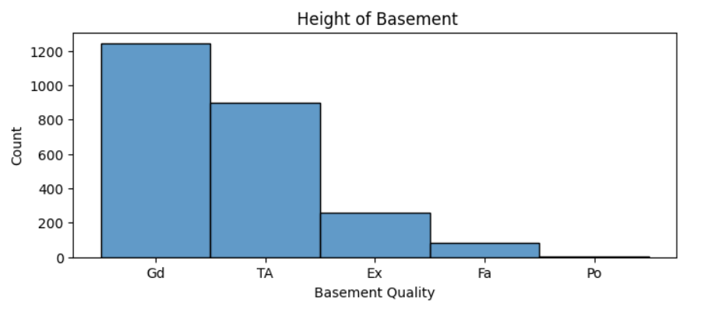

**Basement Condition :** Typical - slight dampness allowed is preffered most often in Basement condition. So construct such basements more in coming future. If basement condition is good, most of the people consider to buy the that specific residence which is well organized. Dampness or some cracking or settling type of basement condition is also choosen while buying residences. People considered in this are average class, middle class. Excellent basement condition is choosen very less. This priority is choosen by high class people. We can see from this graph that very minimal people does'nt choose excellent finished basement. This means that Fully equipped basement is not preffered by maximum people.

**Conclusion :** In future company need to construct basements with “typical - slight dampness”, “dampness or some cracking or settling” and also “good” condition type more in number.

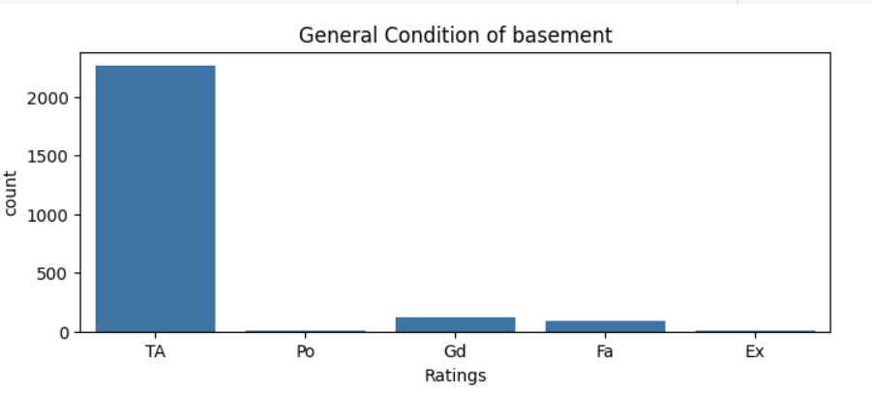

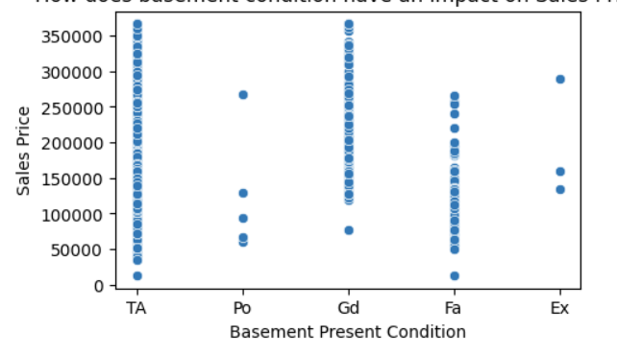

**Basement Exposure :** Good amount of exposure is mostly preffered by people. Even No, Minimum and Average Exposure is selected almost equally. Properties must be build with equal weightage in all kinds of Basement Exposure. There is no specific Exposure of Basement in which customers are specific. So company can construct all kinds of exposure in basement.

**Conclusion :** Company need to construct all kinds of basement exposure as people are intrested in all types of exposure in basement.

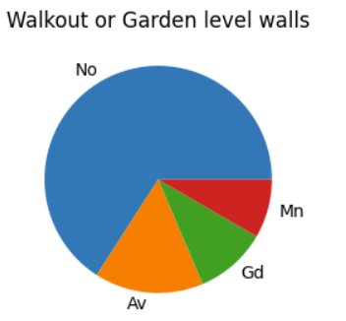

**2) Analyse monthly sales on properties. Which months have selling rate more ?**

**Ans)**

Properties were more sold with maximum amount in January, September, November and December. Also on the month of “June” there were many customer counts to buy fifferent kinds of Plot. On an average every month has sales in good amount. Customers buy land/property/residence in more number in January, November and December because people get year end bonus and hikes. And eveen might save money from January , so they ae able to store good amount to buy residences.

**Conclusion :** January, September, November and December months havehigh rate in sales. So release new properties with highest rates in those months. Also release new properties in month of “June” with all different kinds plot size.

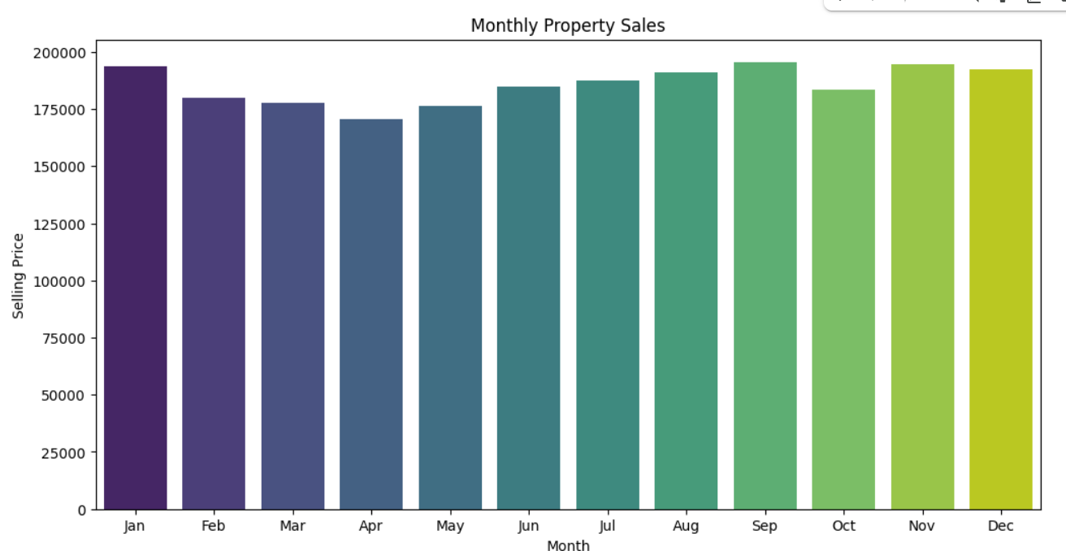

**3) Analyse Lot Area. Which are the top 15 lots that are getting sold ?**

**Ans)**

10,000 square feet is sold in larger number to customers which means buyers are more intrested to buy 10,000 square feet land. 2,500 to 5000 square feet has average count for sales. 100 square feet is mostly preffered by north and south US staying people. Square feets with 30 to 35 range has the second highest sales. 0 to 20 square feet land is prefered by numerous customers for buying. Lands with 40 square feet to 99 squeare feet is not preffered by the people staying in US. Company which gives lands to customers must not create plots with 40 to 99 square feet as no one buys those

**Conclusion :** Company which makes plots in future must not make plots with size40 to 99 square feet as no one buys those. 10,000 square feet land can be created as more count of people preferred it to buy. Also more and more 100 squeare feet land needs to be created much as more frequency members are into 100 sq feet plot.

**4) How does neighbourhood places have an impact on sales of property ? Mention top 5 neighbourhood places selected much by customers .**

**Ans)**

"Clear Creek" is famous place among all other places nearby. "Old Town" is the second famous place among all. Lowest priority was given to "Green Hills". This means most of the people live in "Clear Creek" as their might be all the facilities like schools, colleges, entertainment places, office area's and etc are near to it. "Green Hills" migh not have basic human requirements full pledgely. So people are not interested in that neighbourhood. "Edwards" has the top third priority in selecting the neighbourhood place. "Somerset" has the 4th highest priority in selecting the neighbourhood place. "Northridge Heights" has 5th highest priority in selecting the neighbourhood place. Similarly we can can observe for all other places. Company need to provide more and more plots in top 5 famous places.

**Conclusion :**

Top 5 famous places are “Clear Creek”, “Old Town”, “Edwards”, "Somerset” and “Northridge Heights". This means these are the neighbourhood places in which users are favourable towards. On mentioned 5 places land plots segregation must be more in future.



